Project Design Phase-II TechnologyStack(Architecture&Stack)

|  |  |
| --- | --- |
| Date | 23June2025 |
| TeamID | LTVIP2025TMID60646 |
| ProjectName | Visualizinghousingmarkettrends:ananalysis of the sale prices and using tableau |
| MaximumMarks | 4Marks |

**TechnicalArchitecture:**

TheDeliverableshallincludethearchitecturaldiagramasbelowandtheinformationasperthe table1 & table 2

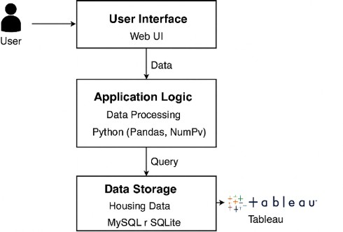

|  |  |  |  |
| --- | --- | --- | --- |
| **S.N**  **o** | **Component** | **Description** | **Technology** |
| 1. | UserInterface | Web-baseddashboardanddata upload UI | HTML,CSS,JavaScript |
| 2. | ApplicationLogic-1 | Datacleaning,transformation,and processing | Python(Pandas,NumPy) |
| 3. | ApplicationLogic-2 | ConnectingprocesseddatatoTableau dashboards | TableauPublic/Tableau Server |
| 4. | ApplicationLogic-3 | KPIcalculation,pricetrendextraction | PythonScripts |
| 5. | Database | Storinghousingdataforfurther querying | MySQLorSQLite |
| 6. | CloudDatabase | Cloudbackuporsharedaccessof datase | GoogleBigQueryorAWS RDS |

|  |  |  |  |
| --- | --- | --- | --- |
| 7. | FileStorage | StoringuploadedCSVsorExcelfiles | AWSS3orLocalFilesystem |
| 8. | ExternalAPI-1 | Geolocationorcity-wiseanalysis | GoogleMaps API |
| 9. | ExternalAPI-2 | OptionalAPIsforhousingmarket  trends | ZillowAPI(ifaccessible) |
| 10 | MachineLearningModel | Predicthousepricebasedonfeatures (optional) | Scikit-learnRegressionModel |
| 11 | Infrastructure(Server /  Cloud) | Localdeploymentfordevelopment,  scalablecloudlater | Localhost(dev),AWSEC2or  Heroku(deploy) |

**Table-2:ApplicationCharacteristics:**

|  |  |  |  |
| --- | --- | --- | --- |
| **S.N**  **o** | **Characteristics** | **Description** | **Technology** |
| 1. | Open-SourceFrameworks | Pandas,NumPy,Flask(forinterface), Scikit-learn | PythonEcosystem |
| 2. | SecurityImplementations | Secure upload (file size/type validation),SHA-256forlogin,HTTPS | Flask-Security,OAuth,SSL |
| 3. | ScalableArchitecture | 3-tierarchitectureallowsindependent scaling of frontend/backend/db | Microservices(optional), Tableau Cloud |
| 4. | Availability | Canbehostedwithauto-scalingon AWS or Heroku | AWSLoadBalancer,Heroku Dynos |
| 5. | Performance | Datacaching,limitedrowquerying, pre-aggregated dashboards | Redis(optional),Tableau Extracts,CDNforassets |